|  |  |  |
| --- | --- | --- |
|  | ***ISTITUTO ISTRUZIONE SECONDARIA SUPERIORE***  ***“E. GIANNELLI”***  **✉ Via Fiume, n. 7 - 73052 PARABITA (LE)**  C.F. 81002570752 ☎ 0833593021 0833509756  www.iissparabita.it – [leis033002@istruzione.it](mailto:leis033002@istruzione.it) |  |

**AR.AC.N.E. 2018**

**Artistic activity proposed by the Czech Republic**

**All the workshops, artistic activities and tourist galleries in CZ will evolve around a famous Czech author, Frantisek Kupka. His work will be an inspiration for Czech activities. All the students will try out some of the techniques for which the artist was famous: wax painting, 3D art, lamination, ceramics.**

**Artistic activity proposed by our Institute**

**Target:**

**Knowledge of the artistic and cultural contribution of the Czech artist to the art of the twentieth century, through the study of some of his most significant works, from those where the artist anticipated the Orphic Cubism of Picasso, to those who have opened the path of abstraction, with its theoretical and technical innovations. The technical experimentation was, in fact, fundamental for such a revolutionary artist!**

**"The art of painting means coating the events that take place in the human soul with plastic forms, and it is a poet-creator to enrich life with new perspectives". František Kupka (1924)**

**Workshops:**

**As first acquaintance of the artist, proposes the vision of a documentary Rai "Kupka, Abstractionism and Modernity".**

**As part of a series of evaluations, they have been able to create abstract works, in particular those in which they can be traced back to Greek art, to the values ​​of an aesthetic extension that is the origin and foundation of our culture.**

**Kupka was fascinated by the Greek Age, and wishing to fill his gaps in the subject, he carefully studied the art of Hellenism and Classicism, which, for the clarity of the design and its conception of composition, is an essential reference for the development of quote pictorial ideas; in Greek art he admired the firm purpose of expressing the meaning of things, the Platonic êidos, that is, the idea involving sensitive bodies. By expressing the general idea, objects and subjects assume a purely abstract character.**

[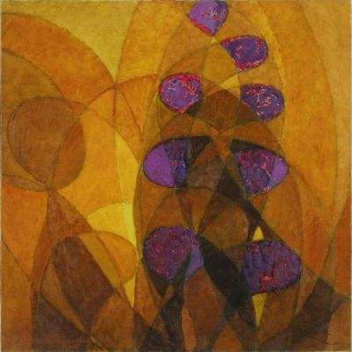](https://archipendolo.files.wordpress.com/2017/11/frantisek-kupka.jpg)

[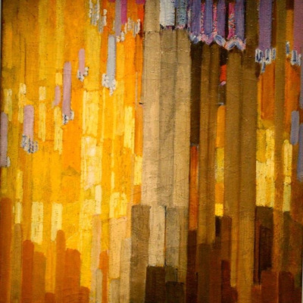](https://archipendolo.files.wordpress.com/2017/11/kupka-19131.jpg)

[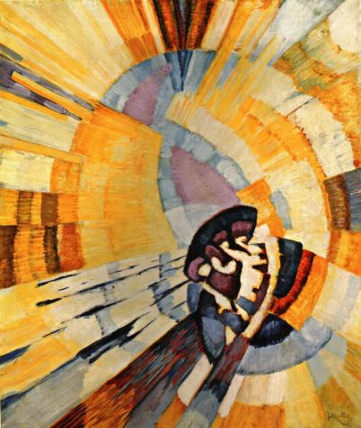](https://archipendolo.files.wordpress.com/2017/11/kupka-astrazione-1913.jpg)

[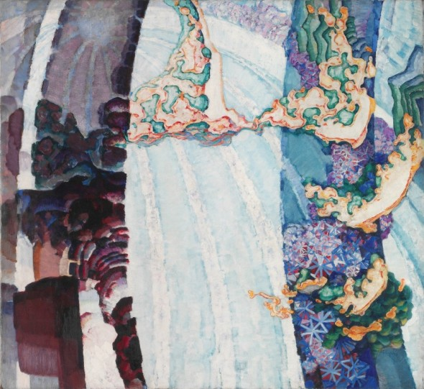](http://www.artslife.com/wp-content/uploads/2018/04/Franti%C5%A1ek-Kupka-Primavera-cosmica-II-1911-20-%C2%A9-Adagp-Paris-2018-%C2%A9-National-Gallery-in-Prague-2018.jpg)

František Kupka – Primavera cosmica II, 1911-20 National Gallery in Prague

[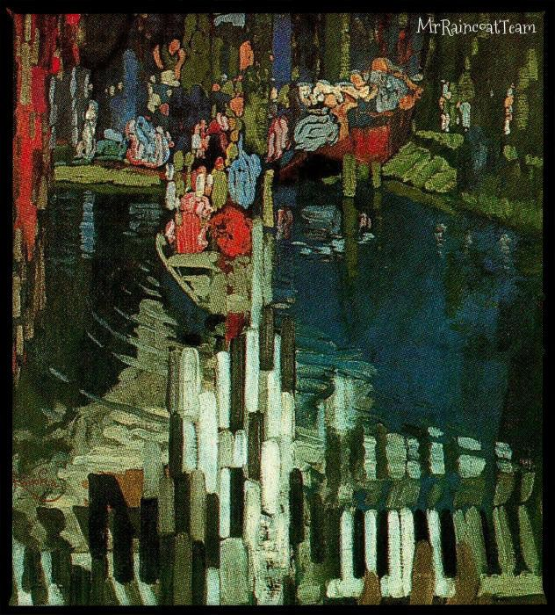](https://lookingformrraincoatblog.wordpress.com/2017/05/21/i-tasti-del-pianoforte-di-frantisek-kupka/)